**SHA 256 Hardware Implementation**

**Version 2**

*Redesign from Version 1:

+ SHA256 PseudoCode:

*Note 1: All variables are 32 bit unsigned integers and addition is calculated modulo 232*

*Note 2: For each round, there is one round constant k[i] and one entry in the message schedule array w[i], 0 ≤ i ≤ 63*

*Note 3: The compression function uses 8 working variables, a through h*

*Note 4: Big-endian convention is used when expressing the constants in this pseudocode,*

*and when parsing message block data from bytes to words, for example,*

*the first word of the input message "abc" after padding is 0x61626380*

*Initialize hash values:*

(first 32 bits of the *fractional parts* of the square roots of the first 8 primes 2..19):

h0 := 0x6a09e667

h1 := 0xbb67ae85

h2 := 0x3c6ef372

h3 := 0xa54ff53a

h4 := 0x510e527f

h5 := 0x9b05688c

h6 := 0x1f83d9ab

h7 := 0x5be0cd19

*Initialize array of round constants:*

(first 32 bits of the *fractional parts* of the cube roots of the first 64 primes 2..311):

k[0..63] :=

0x428a2f98, 0x71374491, 0xb5c0fbcf, 0xe9b5dba5, 0x3956c25b, 0x59f111f1, 0x923f82a4, 0xab1c5ed5,

0xd807aa98, 0x12835b01, 0x243185be, 0x550c7dc3, 0x72be5d74, 0x80deb1fe, 0x9bdc06a7, 0xc19bf174,

0xe49b69c1, 0xefbe4786, 0x0fc19dc6, 0x240ca1cc, 0x2de92c6f, 0x4a7484aa, 0x5cb0a9dc, 0x76f988da,

0x983e5152, 0xa831c66d, 0xb00327c8, 0xbf597fc7, 0xc6e00bf3, 0xd5a79147, 0x06ca6351, 0x14292967,

0x27b70a85, 0x2e1b2138, 0x4d2c6dfc, 0x53380d13, 0x650a7354, 0x766a0abb, 0x81c2c92e, 0x92722c85,

0xa2bfe8a1, 0xa81a664b, 0xc24b8b70, 0xc76c51a3, 0xd192e819, 0xd6990624, 0xf40e3585, 0x106aa070,

0x19a4c116, 0x1e376c08, 0x2748774c, 0x34b0bcb5, 0x391c0cb3, 0x4ed8aa4a, 0x5b9cca4f, 0x682e6ff3,

0x748f82ee, 0x78a5636f, 0x84c87814, 0x8cc70208, 0x90befffa, 0xa4506ceb, 0xbef9a3f7, 0xc67178f2

*Pre-processing (Padding):*

begin with the original message of length L bits

append a single '1' bit

append K '0' bits, where K is the minimum number >= 0 such that L + 1 + K + 64 is a multiple of 512

append L as a 64-bit big-endian integer, making the total post-processed length a multiple of 512 bits

*Process the message in successive 512-bit chunks:*

break message into 512-bit chunks

**for** each chunk

create a 64-entry message schedule array w[0..63] of 32-bit words

*(The initial values in w[0..63] don't matter, so many implementations zero them here)*

copy chunk into first 16 words w[0..15] of the message schedule array

*Extend the first 16 words into the remaining 48 words w[16..63] of the message schedule array:*

**for** i **from** 16 to 63

s0 := (w[i-15] **rightrotate** 7) **xor** (w[i-15] **rightrotate** 18) **xor** (w[i-15] **rightshift** 3)

s1 := (w[i- 2] **rightrotate** 17) **xor** (w[i- 2] **rightrotate** 19) **xor** (w[i- 2] **rightshift** 10)

w[i] := w[i-16] **+** s0 **+** w[i-7] **+** s1

*Initialize working variables to current hash value:*

a := h0

b := h1

c := h2

d := h3

e := h4

f := h5

g := h6

h := h7

*Compression function main loop:*

**for** i **from** 0 to 63

S1 := (e **rightrotate** 6) **xor** (e **rightrotate** 11) **xor** (e **rightrotate** 25)

ch := (e **and** f) **xor** ((**not** e) **and** g)

temp1 := h **+** S1 **+** ch **+** k[i] **+** w[i]

S0 := (a **rightrotate** 2) **xor** (a **rightrotate** 13) **xor** (a **rightrotate** 22)

maj := (a **and** b) **xor** (a **and** c) **xor** (b **and** c)

temp2 := S0 **+** maj

h := g

g := f

f := e

e := d **+** temp1

d := c

c := b

b := a

a := temp1 **+** temp2

*Add the compressed chunk to the current hash value:*

h0 := h0 **+** a

h1 := h1 **+** b

h2 := h2 **+** c

h3 := h3 **+** d

h4 := h4 **+** e

h5 := h5 **+** f

h6 := h6 **+** g

h7 := h7 **+** h

*Produce the final hash value (big-endian):*

digest := hash := h0 **append** h1 **append** h2 **append** h3 **append** h4 **append** h5 **append** h6 **append** h7

+Observation: The two loops (words extension and compression) can be ran in parallel for the the first 48 cycles. Then the words extension can stop and the compression loop keeps on running.

+As such, the loop index control only needs to run from 0 to 63 once for each 512 bits chunk hashing. This fact makes it possible to use only 1 state machine instead of 3 in version 1.

+Each bit rotation and shift operations has its own specialized component (simple routing of inputs to the shifted outputs), thus eliminates the needs for registers to hold the computed values.

+Each computation (48 extended words, temp1, temp2) have its own circuit, thus remove the needs for the registers to hold the computed values.

+ 1: Word extension circuit:

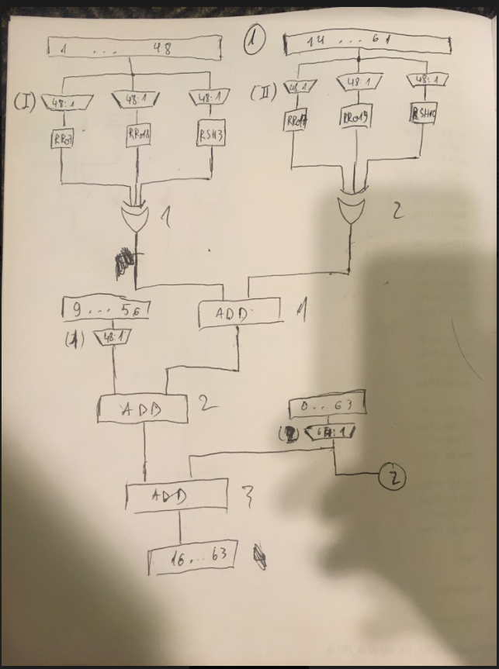

+2: Temp1 calculation; 3: Temp2 calculation

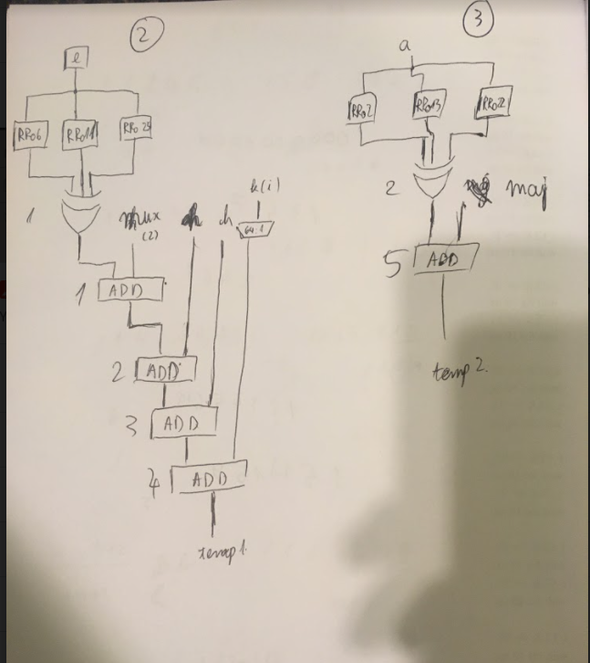

+ Controller:

State machine: In the attached excel file. State machine controls registers I/Os and the loop index counter

Loop index counter: Simple counter counting from 0 to 63. This circuit control the MUXes and DEMUXes.